// SPDX-License-Identifier: Unlicensed

pragma solidity ^0.6.0;

contract MyBank

{

    mapping(address=> uint ) private _balances;

    address public owner;

    event LogDepositeMade(address accountHoder, uint amount );

    constructor () public

     {

         owner=msg.sender;

         emit LogDepositeMade(msg.sender, 1000);

     }

        function deposite() public payable  returns (uint)

        {

        require ((_balances[msg.sender] + msg.value) >  _balances[msg.sender] && msg.sender!=address(0));

        _balances[msg.sender] += msg.value;

        emit LogDepositeMade(msg.sender , msg.value);

        return _balances[msg.sender];

        }

        function withdraw (uint withdrawAmount) public  returns (uint)

        {

                require (_balances[msg.sender] >= withdrawAmount);

                require(msg.sender!=address(0));

                require (_balances[msg.sender] > 0);

                _balances[msg.sender]-= withdrawAmount;

                msg.sender.transfer(withdrawAmount);

                emit LogDepositeMade(msg.sender , withdrawAmount);

                return _balances[msg.sender];

        }

        function viewBalance() public view returns (uint)

        {

            return _balances[msg.sender];

        }

}

Bank Contract Owner: 0x5B38Da6a701c568545dCfcB03FcB875f56beddC4

Sender: 0x4B20993Bc481177ec7E8f571ceCaE8A9e22C02db

Contract address: 0xd9145CCE52D386f254917e481eB44e9943F39138

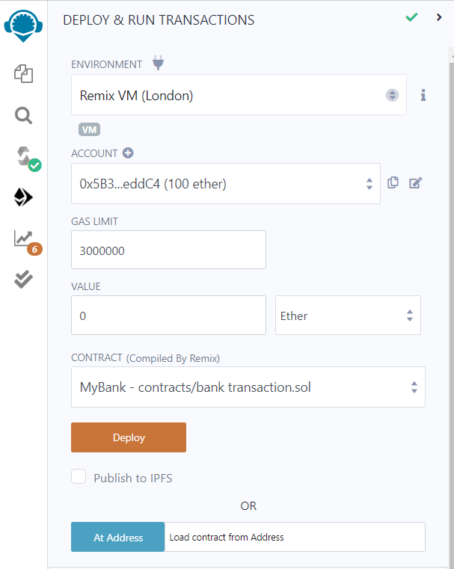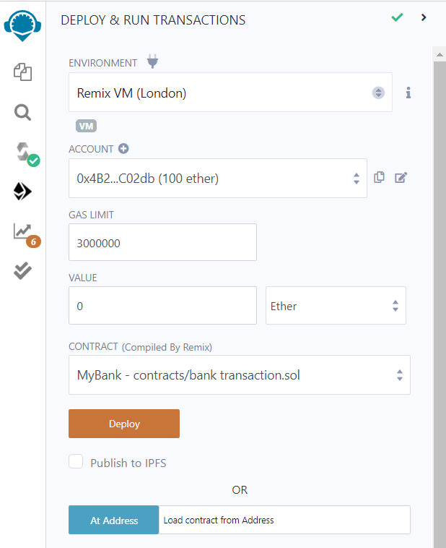

Transaction Log:

[

{

"from": "0xd9145CCE52D386f254917e481eB44e9943F39138",

"topic": "0x3e6eab4ac1d5e706b8c4c295ec0fd5a4ab9f90e15014250d73f946d7625ef64e",

"event": "LogDepositeMade",

"args": {

"0": "0x5B38Da6a701c568545dCfcB03FcB875f56beddC4",

"1": "1000",

"accountHoder": "0x5B38Da6a701c568545dCfcB03FcB875f56beddC4",

"amount": "1000"

}

}

]

Contract Holder Details

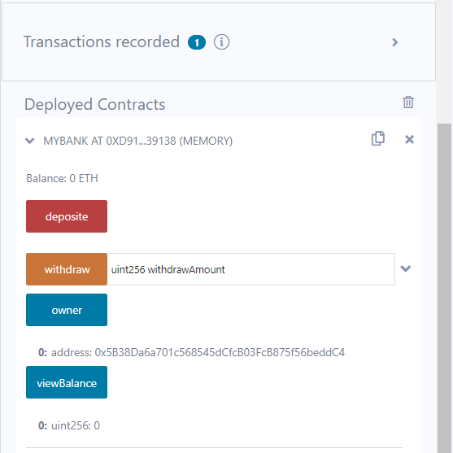

Depositing Ether

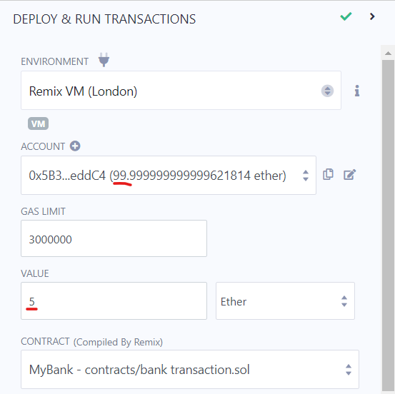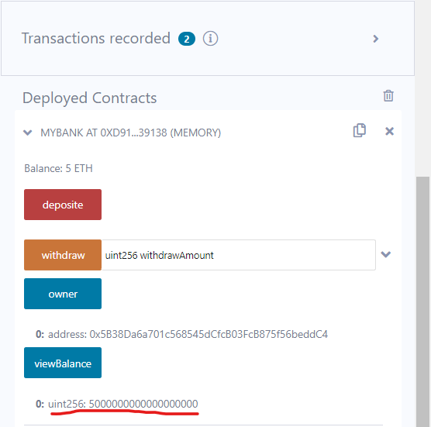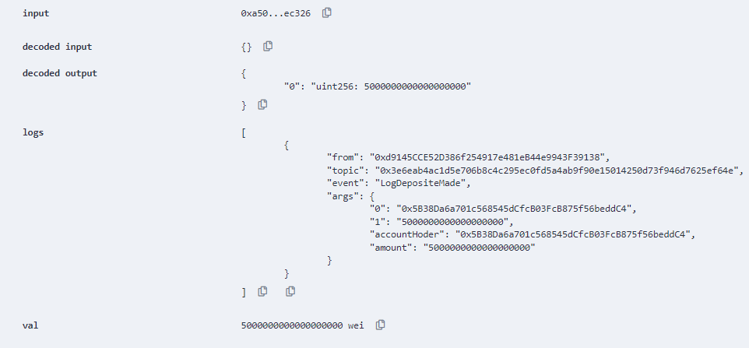

Withdrawing 2 Ethers from Owner with Balance of 5 Ether

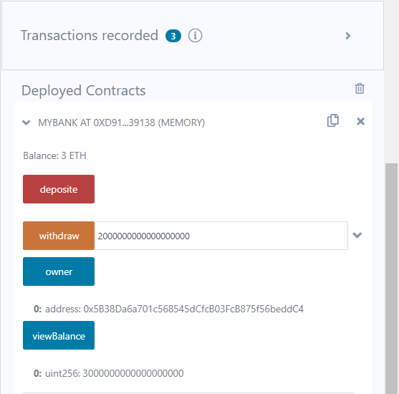

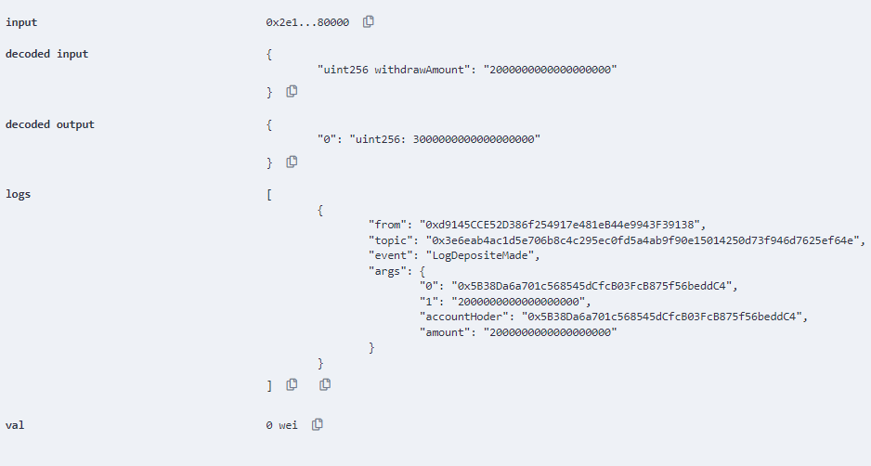

Showing Balance of Account Holder before & after deposit and withdraw

Initial Balance of 5 Ether

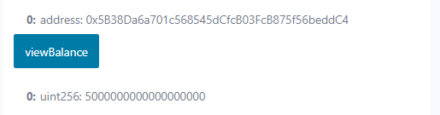

After withdrawing Balance of 2 Ether

